**DAILY ONLINE ACTIVITIES SUMMARY**

|  |  |  |  |  |  |  |  |  |
| --- | --- | --- | --- | --- | --- | --- | --- | --- |
| **Date:** | **28/05/2020** | | | | | **Name:** | **Hanan Saleem Baji** | |
| **Sem & Sec** | **4th SEM 'A' Section** | | | | | **USN:** | **4AL18CS024** | |
| **Online Test Summary** | | | | | | | | |
| **Subject** | | **1. Microcontroller and Embedded Systems**  **2. Aadalitha Kannada** | | | | | | |
| **Max. Marks** | | **1. 20**  **2. 50** | | **Score** | | | **1. 19**  **2. 23** | |
| **Certification Course Summary** | | | | | | | | |
| **Course** | **1.Java Programming** | | | | | | | |
| **Certificate Provider** | | | **1. Great Learning Academy** | | **Duration** | | | **1. 2 hour** |
| **Coding Challenges** | | | | | | | | |
| **Problem Statement:** 1. Write a C program to find digital root of a number.  For example | | | | | | | | |
| **Status: completed** | | | | | | | | |
| **Uploaded the report in Github** | | | | | **Yes** | | | |
| **If yes Repository name** | | | | | 1. <https://github.com/saleemhananbaji/C-coding> | | | |
| **Uploaded the report in slack** | | | | | **Yes** | | | |

ONLINE TEST DETAILS: Online test was conducted on the second module of **Microcontroller and Embedded Systems**. Test contains 20 questions of 1 Mark each. I have scored 19 Marks. And also Aadalitha Kannada test was conducted based on all the chapters. I have scored 23 marks.

Snapshot:

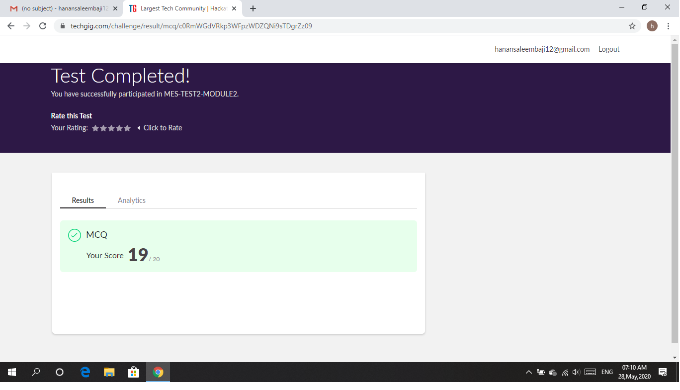

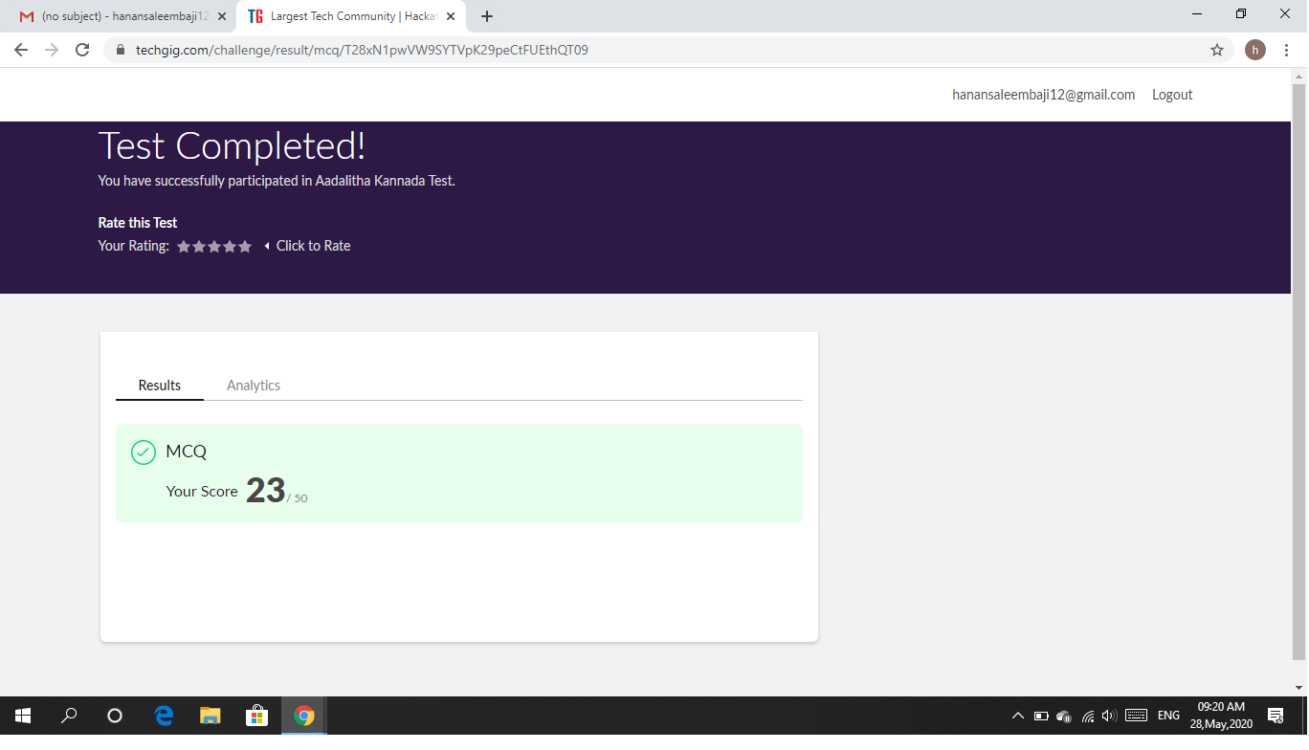

Certification Course Details: As the continuation of Java Programming certification course, I was able complete Object Oriented Programming and Inheritance in Java.

Snapshot:

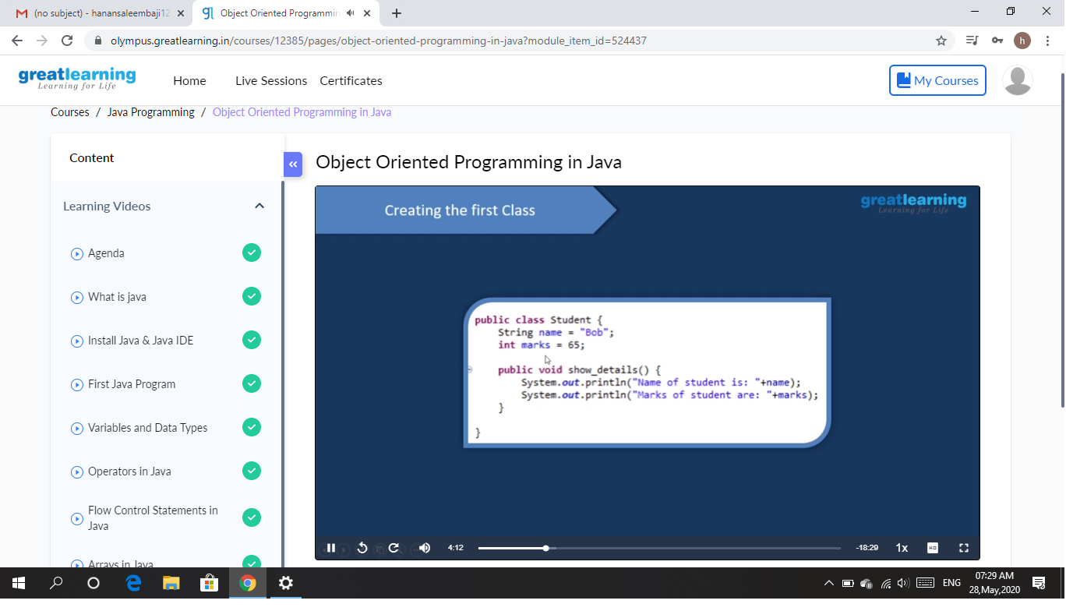

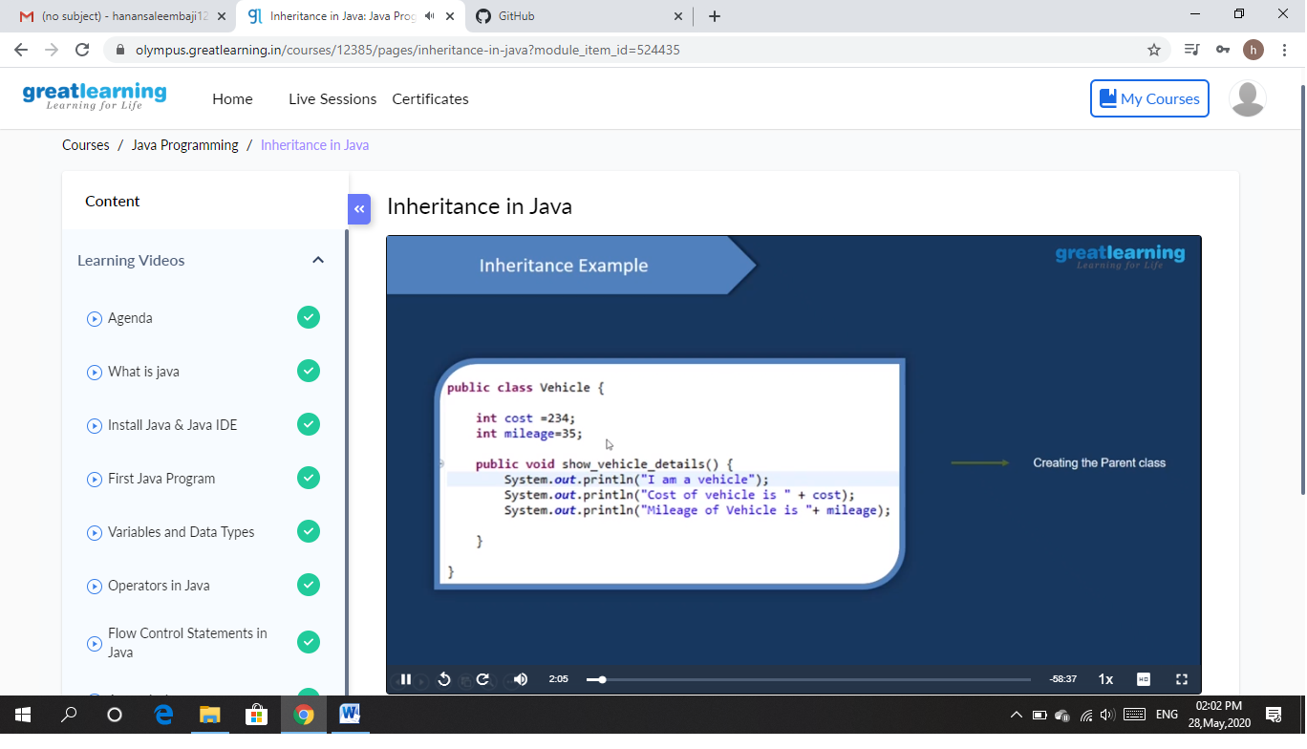

CODING CHALLENGES DETAILS: Problem statements

1. Write a C program to find digital root of a number.

Solution : Uploaded it in github

Snapshot:

